**Predicting Diamond Prices**

|  |  |
| --- | --- |
| Christopher Giler  Udacity Business Analyst Nanodegree | August 16, 2017  Project #1-1 |

# **Step 1: Understanding the Model**

The model for diamond prices is defined as a function of carat, cut, and quality using the following equation:

**Price** = -5,269 + 8,413 x **Carat** + 158.1 x **Cut** + 454 x **Clarity**

1. **According to the model, if a diamond is 1 carat heavier than another with the same cut, how much more should I expect to pay? Why?**

According to the model, if a diamond is 1 carat heavier than another, assuming the same cut and clarity, we can expect the diamond to cost $8,413 more.

1. **If you were interested in a 1.5 carat diamond with a Very Good cut (represented by a 3 in the model) and a VS2 clarity rating (represented by a 5 in the model), how much would the model predict you should pay for it?**

Given the above specifications, our pricing model would predict a cost of $10,094.

# **Step 2: Visualize the Data**

Make sure to plot and include the visualizations in this report. For example, you can create graphs in Excel and copy and paste the graphs into this Word document.

1. **Plot 1 - Plot the data for the diamonds in the database, with carat on the x-axis and price on the y-axis.**

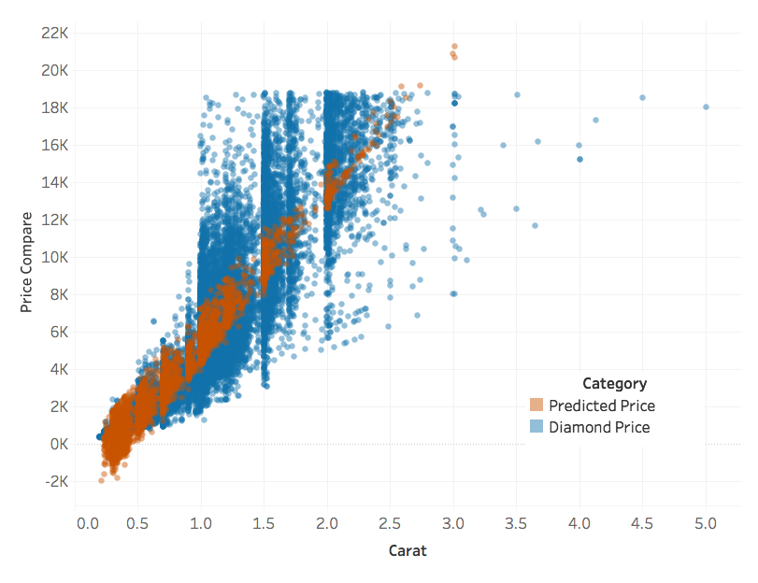

1. **What strikes you about this comparison? After seeing this plot, do you feel confident in the model’s ability to predict prices?**

For higher carats, the predicted prices fall within a reasonable range when compared to actual diamond price data. However, for lower carat diamonds, a number of the predicted prices are negative. These predictions do not make sense in the context of this problem, so we cannot be confident in our price predictions for lower carat diamonds.

# **Step 3: Make a Recommendation**

1. **What price do you recommend the jewelry company to bid? Please explain how you arrived at that number.**

Using the raw predictions, we reach a total price of $11,733,523. This number, however, includes negative values for some diamonds. If we set each predicted price to be a minimum of $0, we see a total retail prediction of $11,870,382. If the jewelry company’s goal is to purchase from the distributor for 70% of the retail price, the recommended price for purchasing the diamonds is **$8,309,267**.